Define Problem Statements

Date | 6 march 2025
Team ID
Project Name | Visualization Tool for Electric Vehicle Charge and Range Analysis
Maximum Marks | 2 marks

Customer Problem Statement Template:
This diagram visualizes the prioritization of ideas for solving key challenges identified in the
Electric Vehicle (EV) sector. Based on multiple user perspectives—including data analysts, EV owners, and policymakers—the visual highlights the most impactful solutions for EV data visualization, charging infrastructure analysis, and user adoption patterns. These were ranked based on impact and ease of implementation to guide development focus.

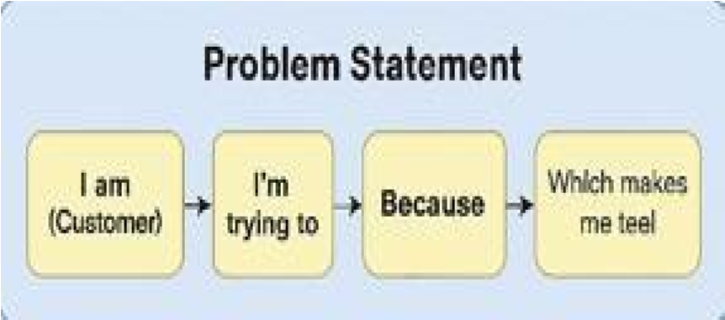

I am  (Customer) | I’m trying to | But | Because | Which makes me feel
EV User in India | understand charging station  availability in my area | data is scattered and hard to access | there is no unified dashboard or platform | frustrated and uncertain about long trips
EV Analyst | analyze sales, usage, and efficiency of EVs globally | datasets are in different formats and not visualized well | manual compilation takes time and loses insights | limited in drawing timely conclusions

Based on these customer insights, the project focuses on analyzing diverse EV datasets and building a visual dashboard to help users and stakeholders make data-driven decisions.

